

Investigating the correlation between weather and domestic heat demand

Minor Project Report

**By:**

Aliya 613274

Karl 617931

Ehssaan 594688

Abdul 602016

**Guided by:**

Carolien Stroomer

Marijn Jongerden

Paul Van Kan

Contents

Contents of Figures iii

Introduction 1

Objective 1

Literature survey 2

Neural Networks 2

Support Vector Machines (SVM) 4

Three Methods and their results 5

Manual implementation of NN 5

Method 5

Algorithm 6

Results 6

NN MATLAB toolbox 10

Method 10

Results 11

Regression MATLAB toolbox 15

Method 15

Results 15

Conclusions 20

Manual implementation of NN 20

NN toolbox 21

SVM with Regression toolbox 21

References 22

# Contents of Figures

Figure 1: Similarity between biological neuron and mathematical construct of a neural network (Richárd, 2019) 2

Figure 2: SVM as large Margin separator 4

Figure 3: NN predicted vs actual Heat production - Test data - with a learning rate of 0.1 (left) and a learning rate of 10 (right) 7

Figure 4: NN output HP/Gas, expected vs actual output – Test Data 7

Figure 5: NN output HP/Gas, expected vs actual output – Training Data 8

Figure 6: Weights of matrices between input layer and hidden layer (left up) and hidden layer and output layer (right up) and biases for hidden layer (lower left) and output layer (lower right). The 4 graphs on the left are from the untrained model, the ones on the right are form the trained model. The axis in the upper graphs denote the neurons (x = previous, y=next) and the colours show the weights (brighter = higher). In the lower graphs, the x-axis shows the number of bias neuron and the y-axis gives the weight size. 8

Figure 7: NN output vs expected values – 50 hidden neurons 9

Figure 8: NN output vs expected values - 150 hidden neurons 9

Figure 9: NN as used by the neural fitting toolbox 10

Figure 10: Input to NN 10

Figure 11: Training data vs Validation and Testing data ratio 10

Figure 12: Hidden layer size 11

Figure 13: Progress report after training 11

Figure 14: Validation Performance 11

Figure 15: Error metrics 12

Figure 16: Combined heat production predicted vs actual – Train data 12

Figure 17: Predicted vs actual Heat production - Test data 13

Figure 18: Predicted vs actual Heat production - Training data 13

Figure 19: Residuals - Test Data 14

Figure 20: Residuals - Training Data 14

Figure 21: k-fold cross validation 15

Figure 22: Error metrics 16

Figure 23: Predicted vs actual heat demand based on temperature 16

Figure 24: Fit of normalised predicted and actual outputs of heat demand 17

Figure 25: Residuals for predicted heat demand 17

Figure 26: SVM - combined heat production predicted vs actual output- Train Data 18

Figure 27: SVM - Predicted Heat production vs actual Heat production -Test Data 18

Figure 28:SVM - Predicted Heat production vs actual Heat production -Training Data 19

Figure 29: SVM- Residuals -Test Data 19

Figure 30: SVM - Residuals - Training Data 20

Figure 31: Linear vs Sigmoid activation function 21

# Introduction

There are 2 broad techniques that are used to predict the future in Big data:

1. Regression

* Linear
* Logistic

2. Machine learning

* Neural networks
* Support vector machines

Regression establishes a mathematical connection between 2 or more variables under consideration.

Machine learning is a study of different algorithms and models such that it learns the patterns of events and inferring what would happen next. It is an integral part of AI (artificial intelligence). Based on current and historical data, a mathematical model is derived and based on the relationship it understands, it makes a predictive analysis. (Wikipedia, Predictive Analytics, 2019)(Wikipedia, Machine Learning, 2019)

Neural networks and Support Vector Machines will be used for this project.

Artificial neural networks (ANN) are systems that are inspired by actual brains and the functions of the neurons. These systems are trained to learn and perform tasks which we teach it to. They can be used for image recognition, medical diagnosis, network filtering, speech recognition and so on.

It is based on a collection of neurons. The sensory neurons (dendrites) are the input neurons, the hidden neurons and then output layer.(Wikipedia, Artifical Neural Networks, 2019)

Support vector machines (SVM) is a supervised learning method like neural networks where a training set is given to the algorithm and it creates a new hyperplane to then categorise new data. It is a black box model. SVMs work as large margin classifiers. It solves classification problems and has a flexible representation of class boundaries.

# Objective

Using neural networks:

* Derive a relationship between weather and heating demand.
* Make predictions of heating demand based on the weather forecast.
* Determine the optimum learning rate, number of iterations (or epochs) and number of hidden neurons.

# Literature survey

## Neural Networks

Performing linear functions are not always preferable. If we have features that have nonlinear terms, calculations get complex and time consuming. Neural networks offer an alternative way to perform machine learning when we have a complex system: many features and complex hypotheses.

They basically mimic our brains to the best of our technology. Just like our brain uses one “algorithm” to learn for different abilities, the neural network attempts to do the same.

Every neuron has dendrites which take inputs from the surroundings as electrical impulses and transmits them to the output through the axon(Figure 1).

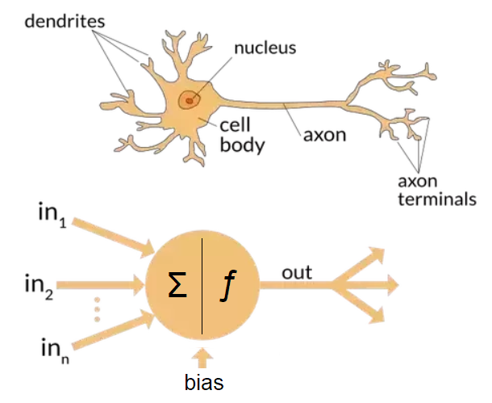

Figure : Similarity between biological neuron and mathematical construct of a neural network (Richárd, 2019)

There are 3 basic layers: input, hidden and output. There can be multiple hidden layers.

The dendrites are input features and a bias unit is added which is always equal to 1.

An activation or a sigmoid function is added which is the same as in the logistic function.

Here, =weights

The output from the input layer is the hypothesis function. The middle layer is also called the **activation layer**. They are represented by and another bias unit is added. The (2) in the superscript is because it’s the second layer.

So now, the flow looks like:

The activation node is obtained by:

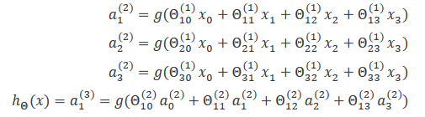

Here, = matrix of weights controlling function mapping from one layer to the next.

The feedforward implementation using vectors is a faster technique and can be achieved as follows:

Assume:

After the row of biases is added:

Now finally the hypothesis is calculated with:

The cost is calculated using:



The last term is called **regularisation** and it is included to avoid overfitting. It does this by removing larger weights.

The cost function should be minimised to the best of capabilities and to achieve this, we use **back propagation**. This can be done using the **gradient** function.

These errors or mismatches are there in the weights

First, set

For

Set

This is calculated also during forward propagation where the *delta* is the difference between the expected and actual output.

For each node, the delta is calculated and the g-prime can be calculated. The g-prime is the derivative of the activation function evaluated with the input values given by and multiplied elementwise.

The delta for each activation layer is calculated either using a vectorised or a non-vectorised function:

The deltas multiplied with their respective activations and dividing by the number of samples, with regularisation gives the gradients.

And

The minimised cost function is now:

Source: (Nguyen, Coursera, 2019)

## Support Vector Machines (SVM)

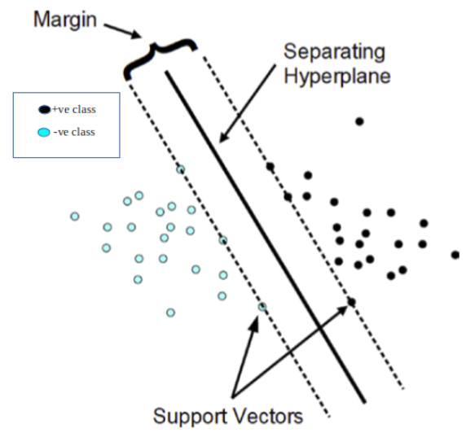

Figure : SVM as large Margin separator

**Terminologies used:**

1. Hyperplane: the decision boundary that differentiates between features
2. Support vectors: the points closest to the hyperplane
3. Margins: the distance of the vectors from the hyperplane

Regions of interests (ROIs) are determined by taking the clusters of information presented in the training set. They are also known as hypothesis generation. A regularisation parameter will determine how much the SVM should avoid misclassifying the training examples. The hypothesis function is given by:

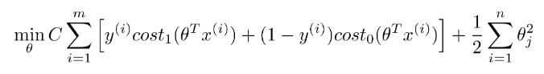

The is chosen according to the amount of bias and the variance we need.

* A large implies lower bias but higher variance
* A smaller implies higher bias but lower variance

With every new data, it is trained better to fit into the kernel. The kernel is decided based on the similarity function. In this project, a medium Gaussian kernel has been used.

Gaussian functions are used to represent a probability density function.

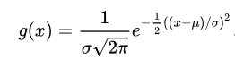

The is chosen such that:

* A larger value has higher bias but lower variance. The features vary more smoothly.
* A smaller value has lower bias and higher variance. The features vary less smoothly.

For the data set:

* Number of training examples =281
* Number of features =6

When , the Gaussian kernel is used. (Nguyen, Coursera, 2019)

A kernel is decided based on the parameters and and it solves for the parameters

**Note:**

* A feature scaling needs to be done before applying Gaussian kernel
* The similarity function needs to satisfy the Mercer’s Theorem which states that the function needs to be a symmetric positive-definite. Some examples of this are polynomial kernel, string kernel, chi-square kernel, histogram and intersection kernel.

# Three Methods and their results

## Manual implementation of NN

### Method

This Project was originally intended to provide more information for the Ecovat Project. As for energy storage a prediction of heat demand would be beneficial, the goal of our work became the prediction of heat demand based on weather data.   
For this project, 2 datasets were used. One of these datasets was delivered by a member of HAN. It contains the weekly heat production of a house with a heat pump and a gas heating. This dataset would provide the information about the heat demand, the output of the model. The other dataset used was the weather data of the closest weather station (Instituut, 2019). This dataset would provide the inputs to the model, consisting of the average weekly temperature, the average weekly windspeed, the average weekly sunshine duration the overall sum of sunshine duration, the average hourly precipitation and the sum of precipitation per week. This data was gained from hourly values provided by the Dutch weather service.

The heat production data was manually cleaned to get rid of outliers, measurement errors and other unwanted values. Dimensions of each column were checked, gaps filled and intervals between data checked for uniformity. As the heat production was given as an accumulative sum, the heat production per week needed to be extracted.

A neural network with one hidden layer was then trained with this data. The Neural net was based on the exam given in BDSD class. As the NN delivered good results for that application, it can be safely assumed, that this NN was well implemented.

To feed the data into the NN, the data preparation was adjusted to read the data properly. The size of input and output neurons was now automatically bound to the number of inputs and outputs.

For the NN to function properly, the data was normalized with the z-score function.

The data was split to 70% for training and 30% for testing.

As the NN was doing classification in the assignment, the evaluation had to be changed as well. New error metrics for this prediction model had to be established. Mean absolute Error, mean absolute relative error and mean absolute percentage error are a few to name.

Now the network could be run with different numbers of hidden neurons and different learning rates.

### Algorithm

1. Randomly initialise the weights
2. Implement forward propagation to get for any
3. Implement the cost function
4. Implement back propagation to compute partial derivatives
5. Use gradient checking to confirm that your backpropagation works.
6. Use gradient descent to minimise cost function with the weights in theta

### Results

For the training, a learning rate of 1 with a maximum number of 500000 epochs was chosen. Other learning rates were tried with no better results(Figure 3).

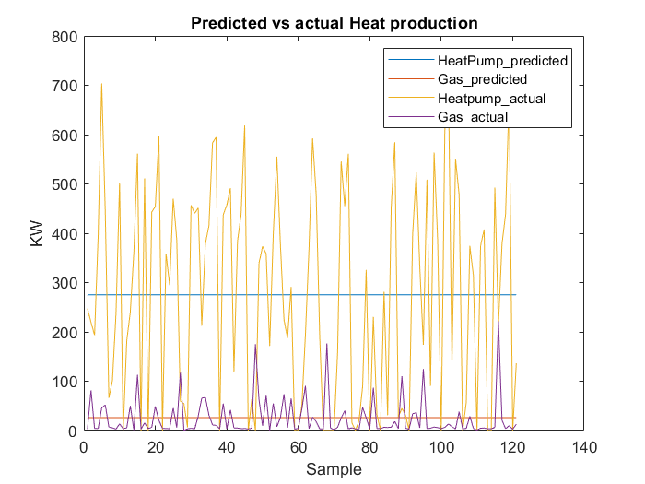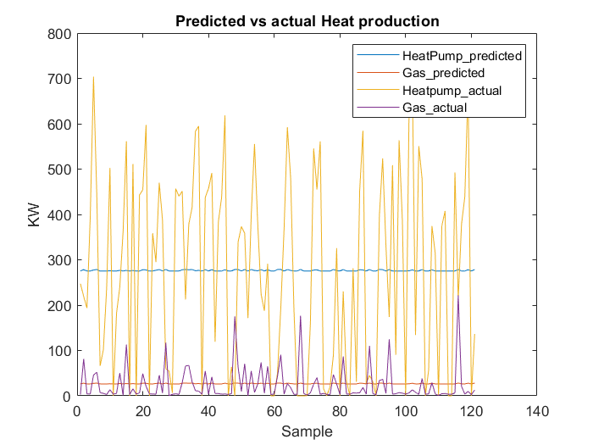

Figure : NN predicted vs actual Heat production - Test data - with a learning rate of 0.1 (left) and a learning rate of 10 (right)

The NN was trained with 10 hidden neurons. This was seen as a reasonable size, as it lies close to the sum of number of input- and output neurons.

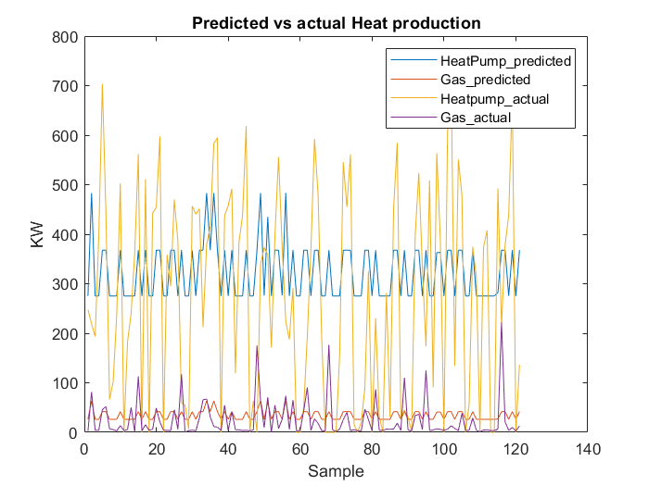

Figure 4: NN output HP/Gas, expected vs actual output – Test Data

As can be seen (Figure 4), the predictions of the neural network did not match up with the actual values. To get a better idea, the predictions on the training data was plotted.

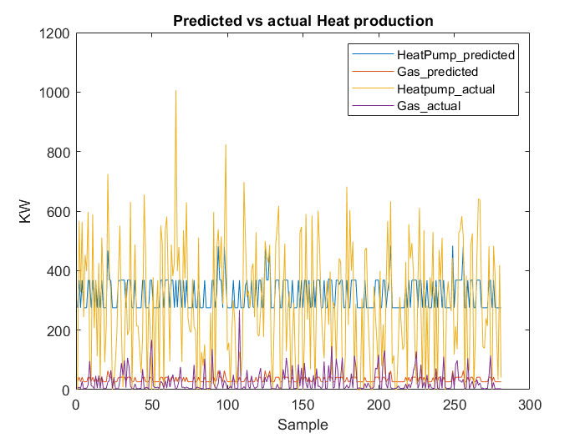

Figure 5: NN output HP/Gas, expected vs actual output – Training Data

Even with the training data the predictions fail to match the expected values (Figure 5). To make sure, the training of the network is actually doing something, it helps to compare the weights of the matrices:

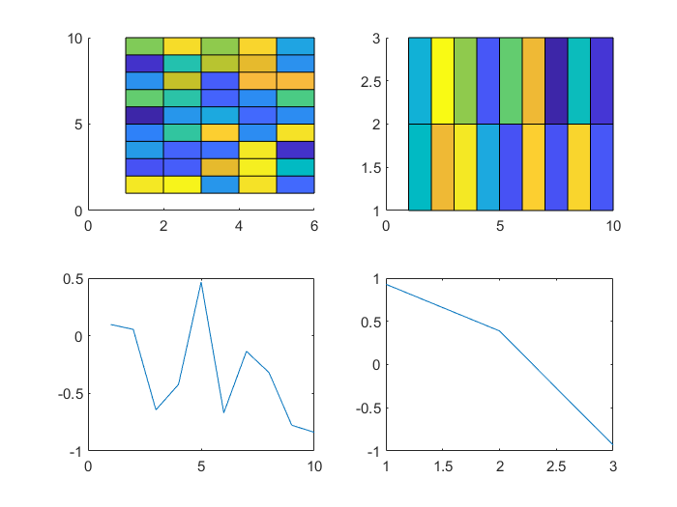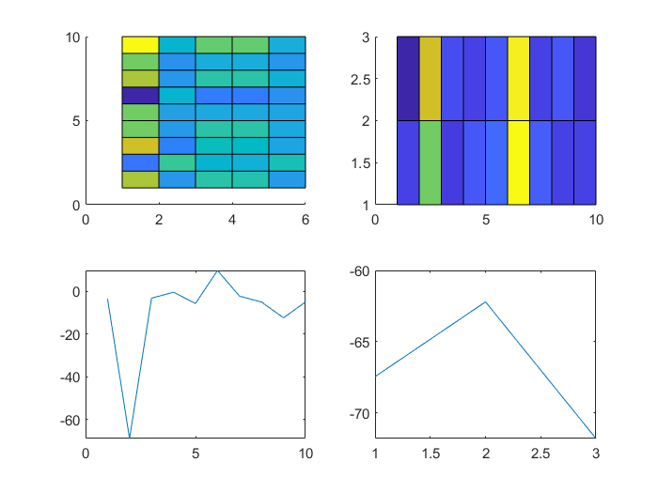

Figure 6: Weights of matrices between input layer and hidden layer (left up) and hidden layer and output layer (right up) and biases for hidden layer (lower left) and output layer (lower right). The 4 graphs on the left are from the untrained model, the ones on the right are form the trained model. The axis in the upper graphs denote the neurons (x = previous, y=next) and the colours show the weights (brighter = higher). In the lower graphs, the x-axis shows the number of bias neuron and the y-axis gives the weight size.

From the graphs in Figure 6, it can be seen, that the training actually does something. As the training seems to be somewhat functioning, a bigger hidden layer is used.

The NN needs ca. 45 seconds to train on this data with 50 hidden neurons. The output of the NN can be compared with the expected values in the following graphs: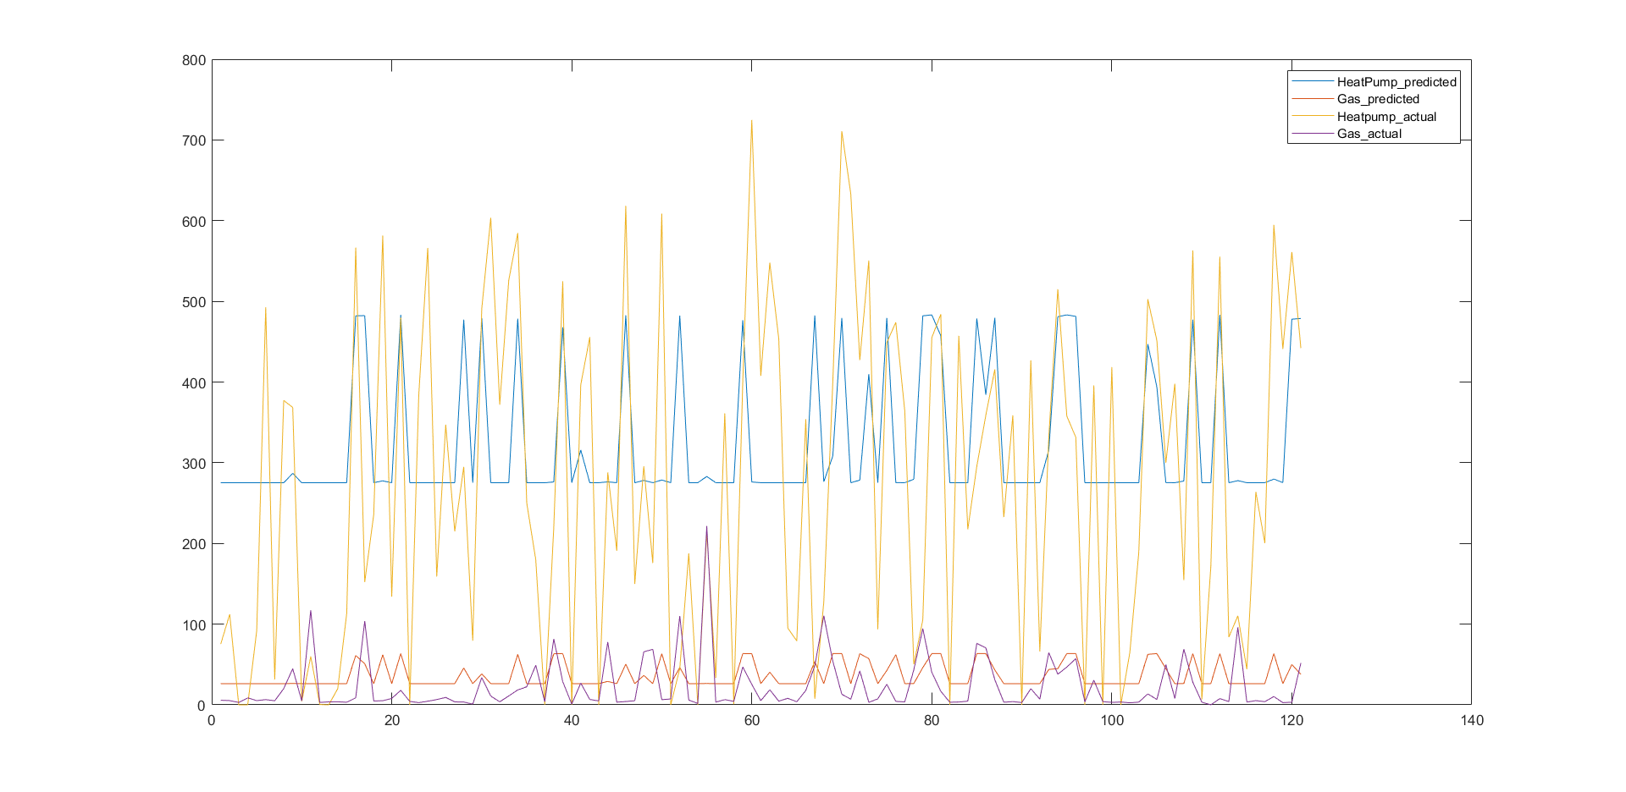

Heat production

Samples

Figure 7: NN output vs expected values – 50 hidden neurons

It can be seen, that the NN is trying to adjust to the values (Figure 7). Nevertheless, it does not manage to meet the expected values. for the Heatpump prediction, the values seem to be bounded and the Gas prediction seems to have an offset. Similar outputs can be observed over several training attempts.

Increasing the number of hidden neurons to 150 blows up the training time to 123s. the results can be seen in the following graph:

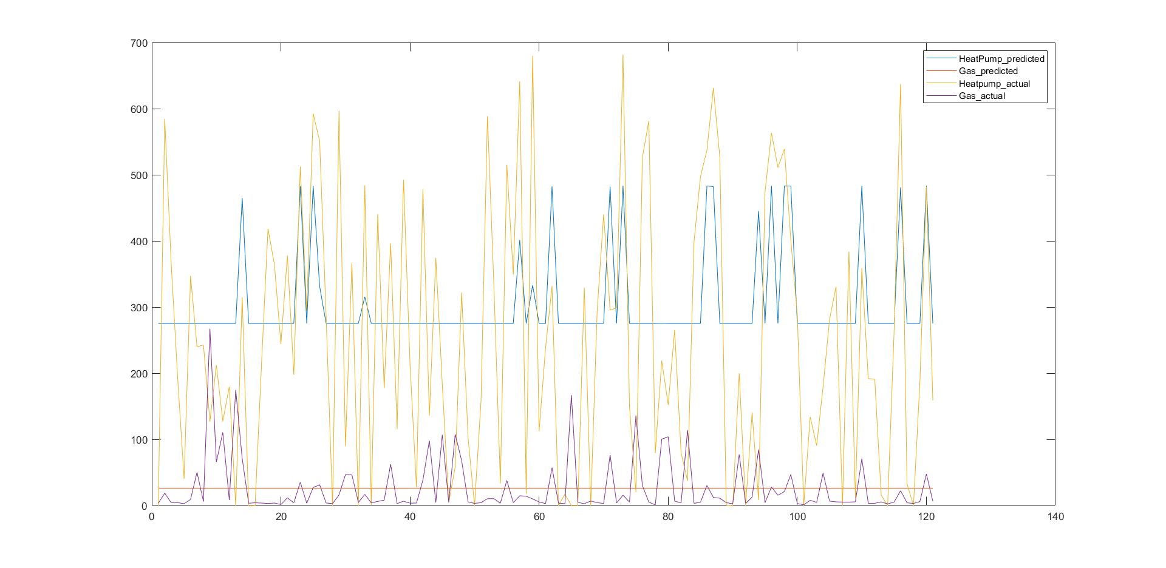

Samples

Heat production

Figure 8: NN output vs expected values - 150 hidden neurons

As the results do not get any better , it can be safely assumed, that a further increase in neurons will not improve the results.

The mse (mean squared error) can be found in the following table.

Table : MSE(norm)-self built NN

|  |  |  |
| --- | --- | --- |
| MSE (norm) | TrainingData | Test Data |
| Heatpump | 0.833089 | 0.917945 |
| Gas | 0.799337 | 0.910937 |
| Combined | 0.935919 | 1.080433 |

## NN MATLAB toolbox

### Method

As the results with the manual implementation of the NN were not satisfying, the NN MATLAB toolbox for neural fitting was applied to the data. This toolbox applies a 2-layer feed-forward network with sigmoid hidden neurons and linear output neurons (Figure 9).

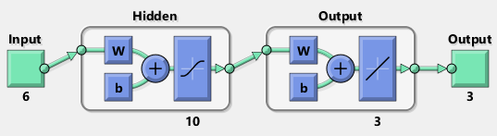

Figure 9: NN as used by the neural fitting toolbox

This network is then fed with the x_train and y_train previously generated for the manual implementation of the NN (Figure 10).

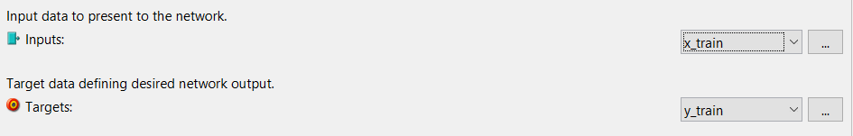

Figure 10: Input to NN

The training data set is then split up into training- test- and validation- set (Figure 11). This splitting cannot be reduced to zero. As it is a toolbox function, the validation and test dataset was seen as part of the overall training algorithm, so the values were not changed. This data splitting is unconnected to the initial splitting between test and validation set. Here the training data set is internally split up by the toolbox.

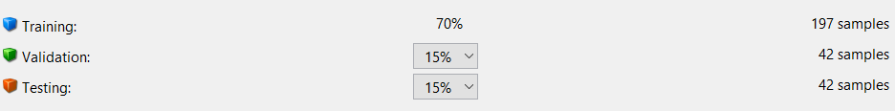

Figure 11: Training data vs Validation and Testing data ratio

For the hidden layer 10 neurons are chosen as in the first attempt with the self made NN (Figure 12).



Figure 12: Hidden layer size

### Results

The nntraintool automatically determines the right amount of iterations.

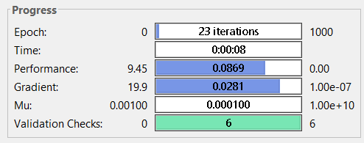

Figure 13: Progress report after training

From the validation performance (Figure 14), it can be clearly seen, that the NN is being trained quickly. By the validation performance it is determined, that at epoch 17 the NN delivers best performance so training can be stopped.

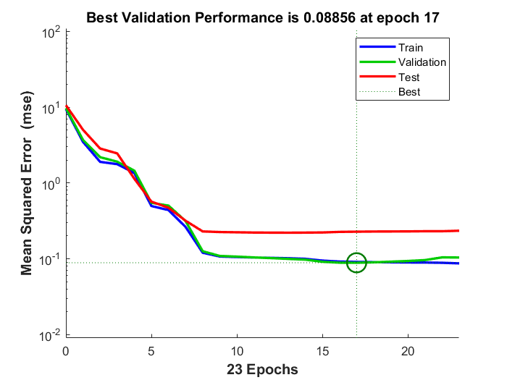

Figure 14: Validation Performance

The toolbox already delivers its own quality measures (Figure 15). The MSE (Mean Squared Error) measures the average of the squares of the errors—that is, the average squared difference between the estimated values and what is estimated. The closer the MSE is to zero, the better the fit. As the MSE is very low here, there seems to be a good fit with the data.

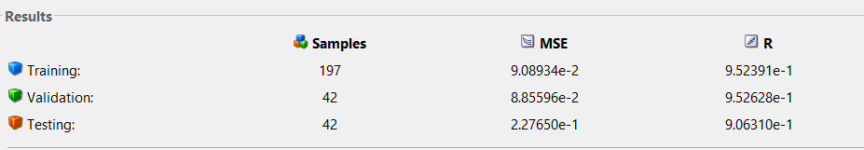

Figure 15: Error metrics

The trained network can then be fed again with the training data set (Figure 16). A good fit with the training data can be already observed here.

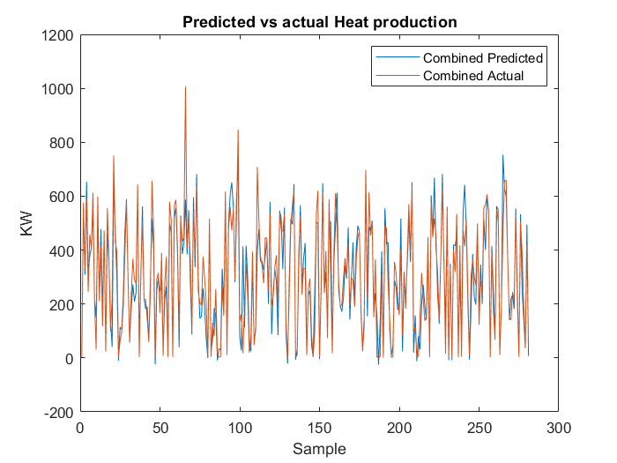

Figure 16: Combined heat production predicted vs actual – Train data

When feeding the NN with the test data, a relatively good prediction can be seen (Figure 17).

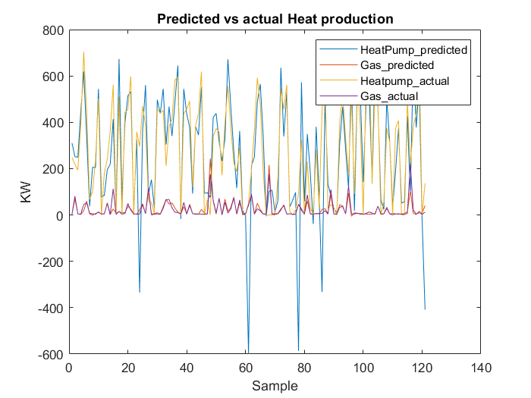

Figure : Predicted vs actual Heat production - Test data

There are a few big outliers giving negative heat production for the heatpump (Figure 17).

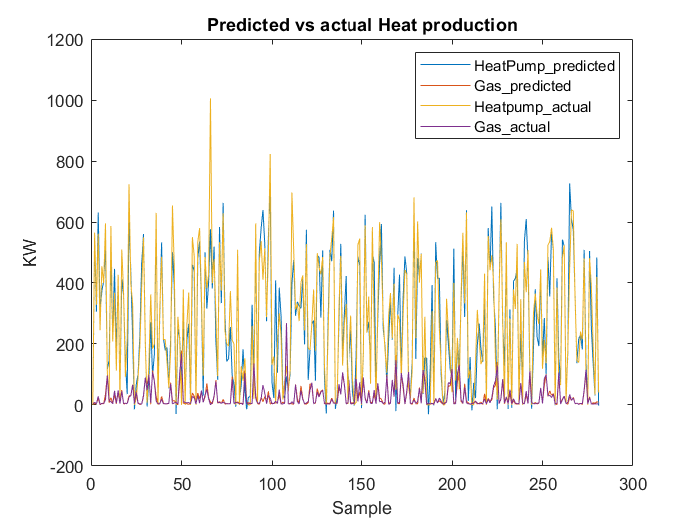

Figure : Predicted vs actual Heat production - Training data

This behaviour cannot be spotted on the training data (Figure 18) and was never observed for previous training attempts.

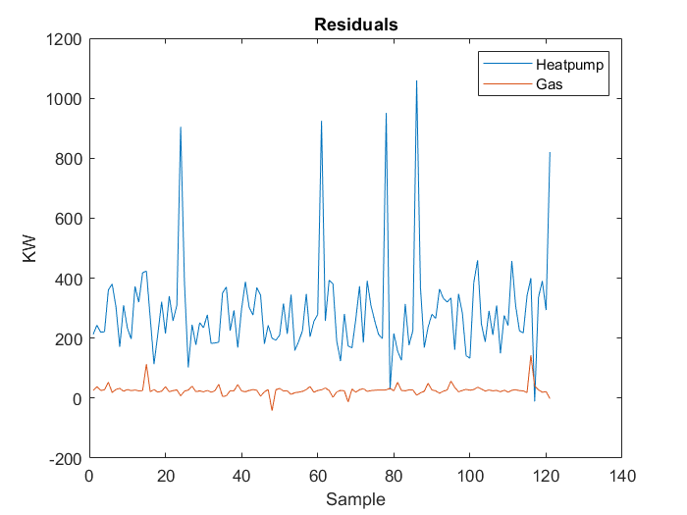

Figure : Residuals - Test Data

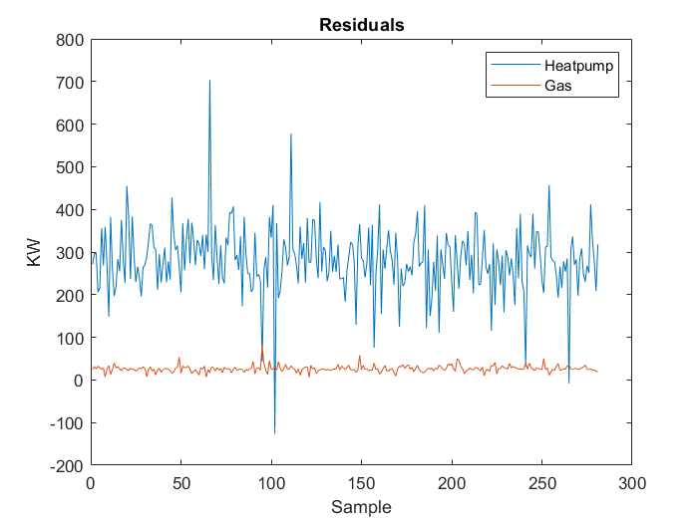

Figure : Residuals - Training Data

The residuals both for training (Figure 20) as well as for test data (Figure 19) are roughly in the same range.

It can be assumed, that the negative outliers in the heating prediction of the test set are simply the result of a bad seed.

The mse (mean squared error) can be found in the following table.

Table :MSE(norm)-nftool

|  |  |  |
| --- | --- | --- |
| MSE (norm) | TrainingData | Test Data |
| Heatpump | 0.144817 | 0.593376 |
| Gas | 0.044751 | 0.218106 |
| Combined | 0.136688 | 0.586856 |

## Regression MATLAB toolbox

### Method

The regression SVM toolbox in MATLAB was employed. Using the regression model through SVM (Gaussian kernel) function, the root mean square error (RMSE) is very small and so are the other error metrics. A 5-fold cross validation is used to validate the model (Figure 21).

Cross validation is also called a rotation estimation. It’s very easy to see how accurately the predictive model will perform in practical settings. The data is divided into 5 portions of test data sets and training data sets for each iteration. The same test set is not used for all iterations. This testing is just an internal metric of the toolbox and can be seen as part of the training algorithm. It is independent of the initial splitting into test and training data. The cross validation is purely run on the training data.

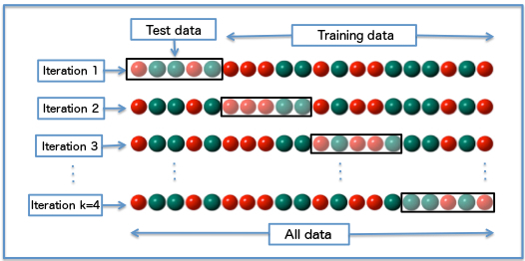

Figure 21: k-fold cross validation

### Results

The error metrics RMSE, R-Squared, MSE and MAE as given by the toolbox are observed and all of them are small (Figure 22).

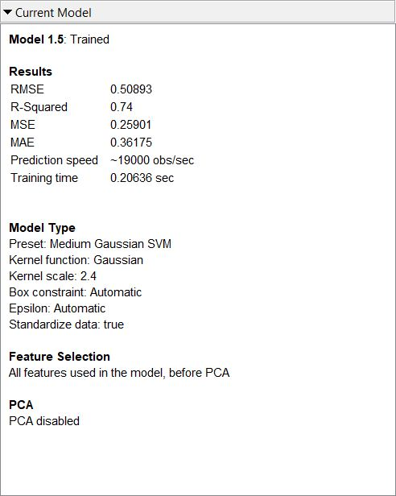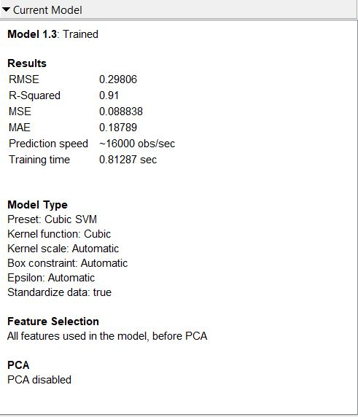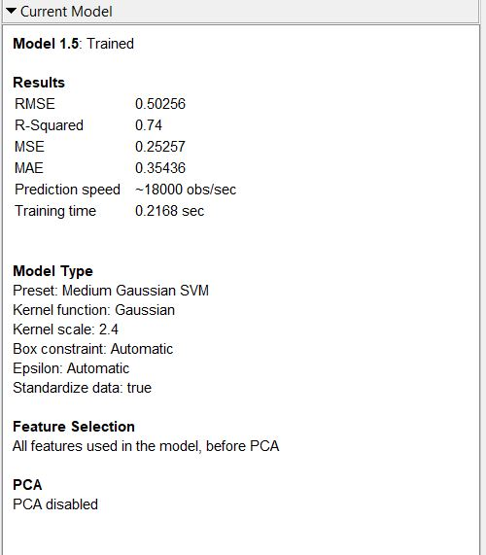

Figure 22: Error metrics and parameters for Heat pump (left), Gas (middle) and combined (right)

In the graph below (Figure 23), the graph corresponds to the **actual** heat production and the **predicted** heat production as given by the toolbox. It can be seen here that there is a good correlation between the output (heat demand) and the temperature (x-axis, column_1).

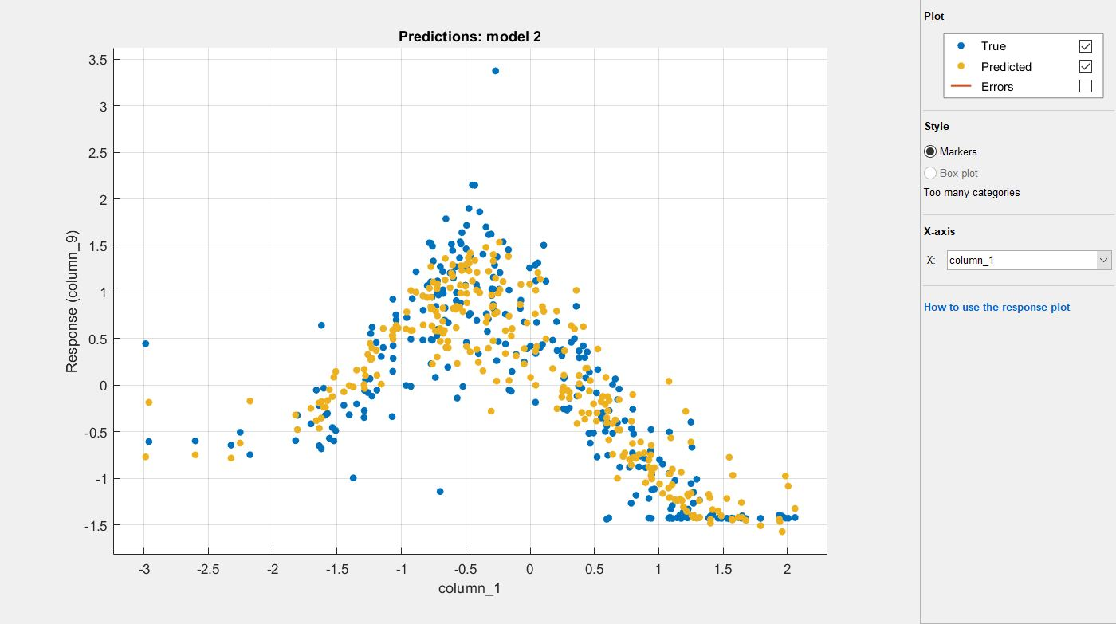

Figure 23: Predicted vs actual heat demand based on temperature

The graph below (Figure 24) shows the fit of the actual and predicted responses as given by the toolbox. The linear graph is the ideal fit. The closer the points are to each other and the ideal line, better the fit. As can be seen, it’s a good prediction model.

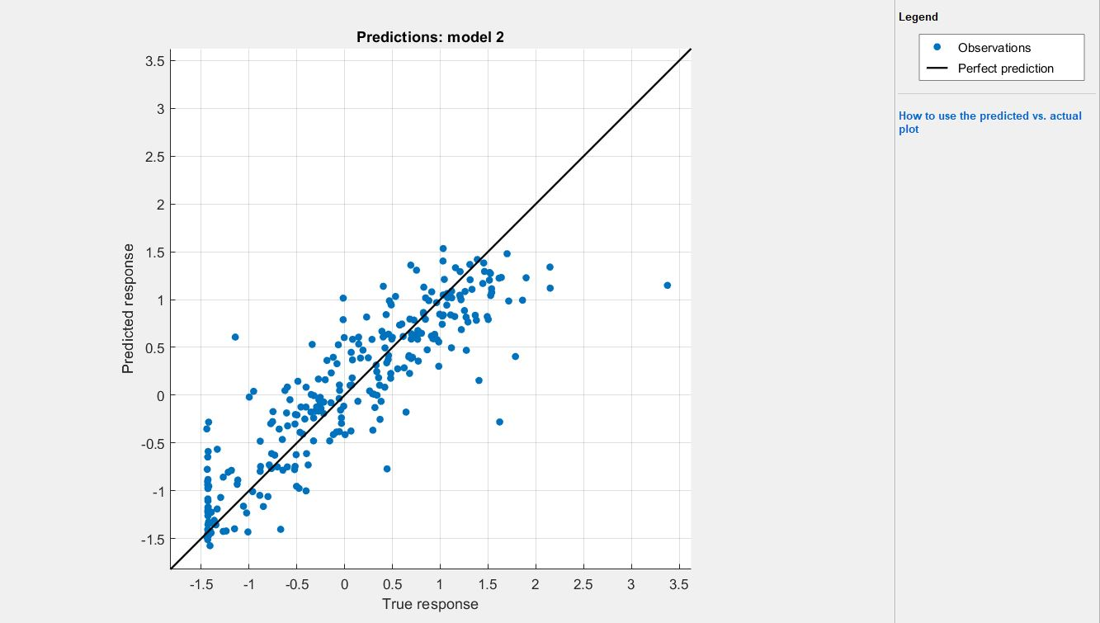

Figure 24: Fit of normalised predicted and actual outputs of heat demand

The graph below (Figure 25) shows the residuals as given by the toolbox with respect to the predicted response. For the normalised values that range between -1.5 and 1.5, the residuals are lower for the lower end and increases with an increase in normalised values.

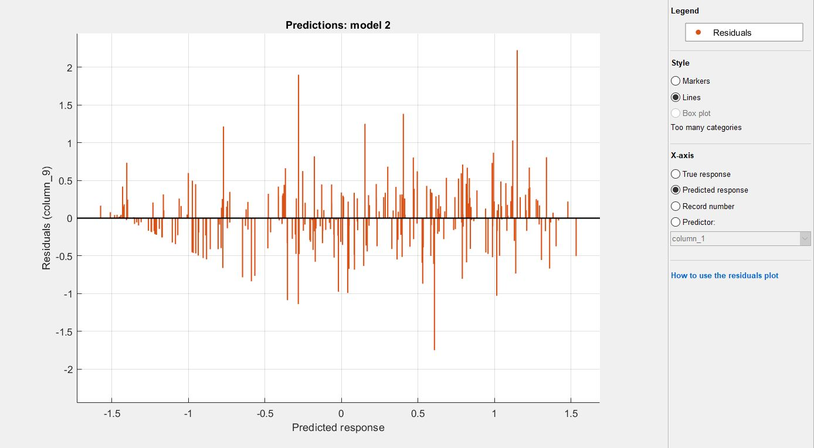

Figure 25: Residuals for predicted heat demand

When feeding the model with the training data, a good fit can be already observed for the combined output (Figure 26).

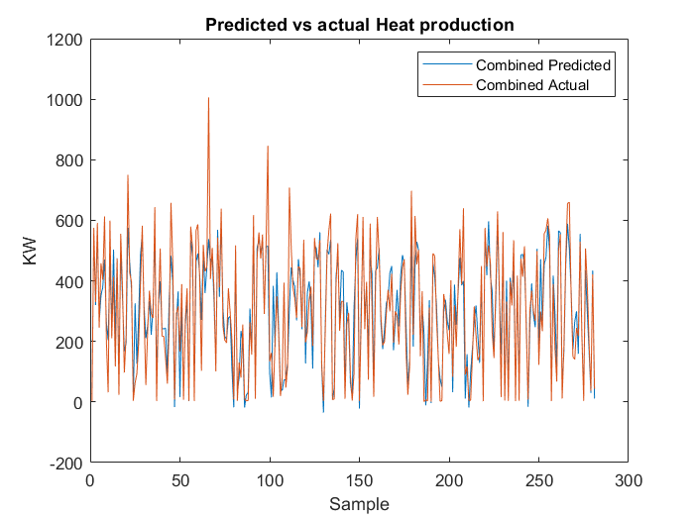

Figure 26: SVM - combined heat production predicted vs actual output- Train Data

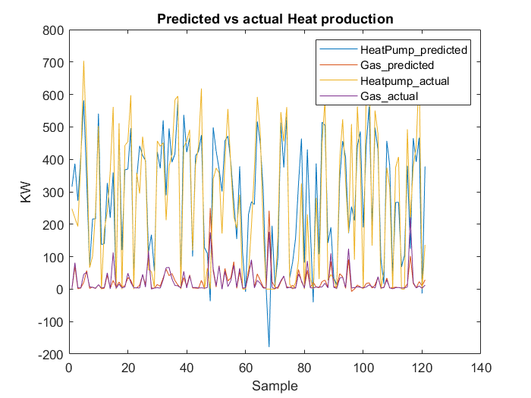

Figure : SVM - Predicted Heat production vs actual Heat production -Test Data

The predictions on the test data match the expected values well, especially the prediction of Gas Heat production (Figure 27). The match with the training set does not show any significant unexpected predictions (Figure 28).

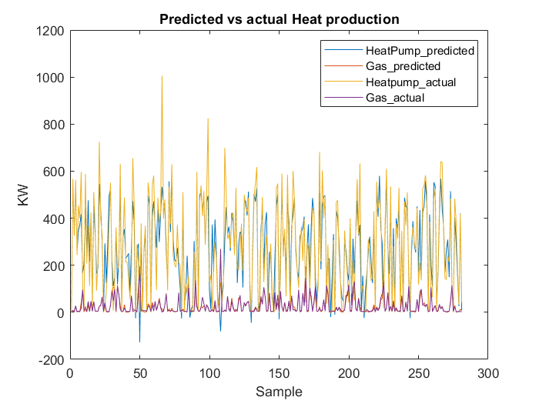

Figure :SVM - Predicted Heat production vs actual Heat production -Training Data

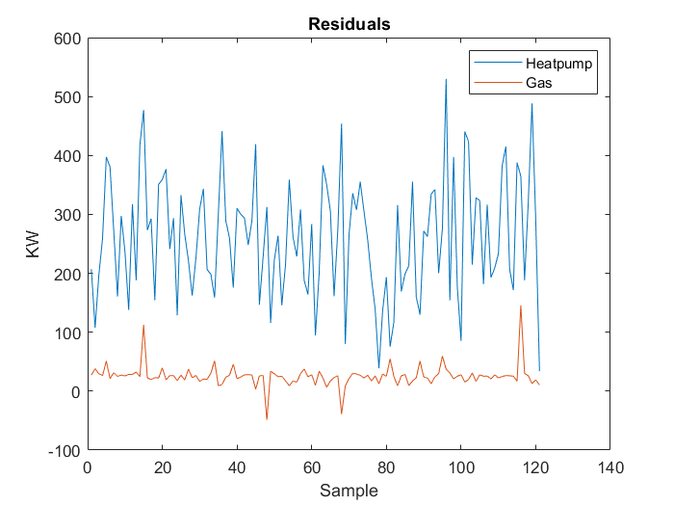

Figure : SVM- Residuals -Test Data

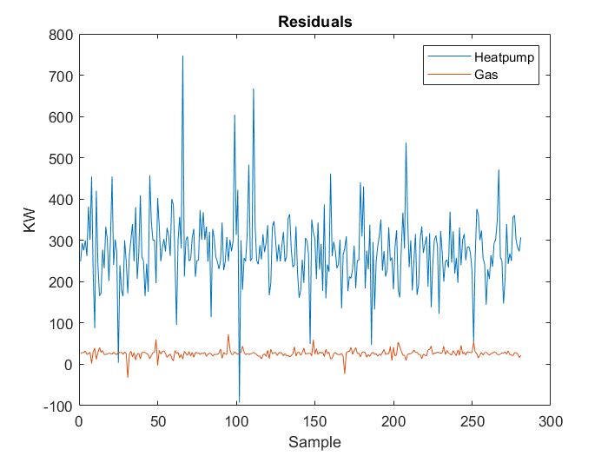

Figure : SVM - Residuals - Training Data

The residuals for both training (Figure 30) and test data (Figure 29) lie within the same range.

Below, the MSE table can be found.

Table : MSE(norm)-SVM (regression toolbox)

|  |  |  |
| --- | --- | --- |
| MSE (norm) | TrainingData | Test Data |
| Heatpump | 0.178197 | 0.238478 |
| Gas | 0.060874 | 0.249772 |
| Combined | 0.167937 | 0.245215 |

# Conclusions

## Manual implementation of NN

The Manual implementation of the NN did not manage to train on the given dataset. As the NN had already proven to be implemented correctly, it was assumed, that the heating demand cannot be predicted from this weather data with this type of NN.

Next steps would have been using a different algorithm like linear regression or a NN with more hidden layers.

Another way to get usable results that was proposed was the use of a better dataset. This dataset was given for a single household with only one person living there. The heat demand will be influenced a lot by different daily routines of this person. Gathering a dataset from a bigger house with several apartments would give a more averaged view and cancel out the individual heat demands of each apartment.

Also feeding the NN with daily values could improve on the results, as the weather data is available even hourly. Together with that improvement, the day of the year could also be given to the NN, so it gets a clue about different times of the year.

A final way to improve the dataset would be gathering actual heat consumption data and splitting these up between heating and hot water demand. This would allow to correlate the actual heat demand with the weather and minimize the noise introduced by the hot water demand.

After running the NN toolbox and the regression toolbox on the data though, it could be seen, that the data actually gives enough information for prediction. Nevertheless, the noted improvements on the dataset would still provide better results with any prediction method.

## NN toolbox

With the NN toolbox a good prediction for the heat production from weather data could be made. This shows, that the manual implementation of the NN was not done correctly. The cause for the discrepancy could not be found though.

A reason for that discrepancy could be the difference in the output activation. While the manual implementation of the NN uses a sigmoid activation function in the output layer, the NN toolbox uses a linear activation function (Figure 31).

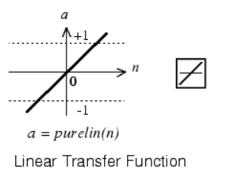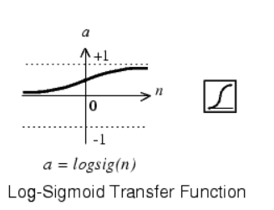

Figure 31: Linear vs Sigmoid activation function

## SVM with Regression toolbox

The SVM with the regression toolbox can find a correlation in the data, especially with the temperature input. The MSE for the SVM are even better than the ones of the neural network generated with the toolbox. Also the MSE on the test data is best for the SVM generated with the regression toolbox. . Although it needs training for each output individually, the SVM gives the best predictions of all 3 methods.

# References

Instituut, K. N. (2019, 06 15). *Uurgegevens van het weer in Nederland - Download*. Opgehaald van Klimatologie: http://projects.knmi.nl/klimatologie/uurgegevens/selectie.cgi

Nguyen, A. (2019, 06 27). *Coursera*. Opgehaald van Machine Learning: https://www.coursera.org/learn/machine-learning/

Nguyen, A. (2019, 06 17). *Coursera*. Opgehaald van Machine Learning: https://www.coursera.org/learn/machine-learning/

Richárd, N. (2019, 06 17). *Towards Data Science*. Opgehaald van The differences between Artificial and Biological Neural Networks: https://towardsdatascience.com/the-differences-between-artificial-and-biological-neural-networks-a8b46db828b7

Wikipedia. (2019, 06 16). *Artifical Neural Networks*. Opgehaald van Wikipedia: https://en.wikipedia.org/wiki/Artificial_neural_network

Wikipedia. (2019, 06 16). *Machine Learning*. Opgehaald van Wikipedia: https://en.wikipedia.org/wiki/Machine_learning

Wikipedia. (2019, 06 16). *Predictive Analytics*. Opgehaald van Wikipedia: https://en.wikipedia.org/wiki/Predictive_analytics